**VSD TCL WORKSHOP**

**DAY 1**

Day 1's task is to create a command (in my case, synui) and pass a .csv file from the UNIX shell to the TCL script, taking into consideration mainly the general scenarios from the user's point of view.

**Task:**

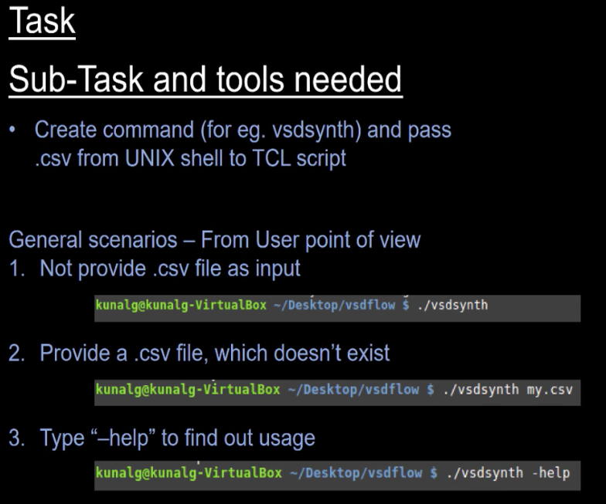

**Inputs File:**

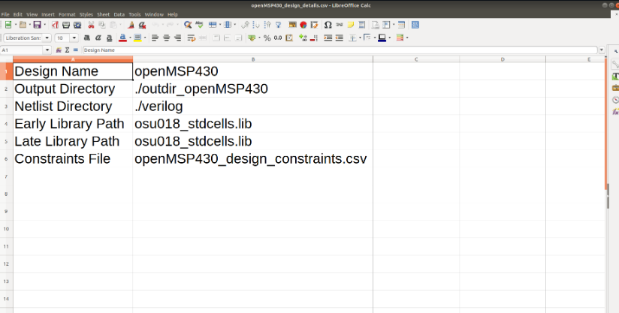

**Implementation:**

1. Creating the ./synui command by writing a bash script to cover the general scenarios of input file present or not.

Script:

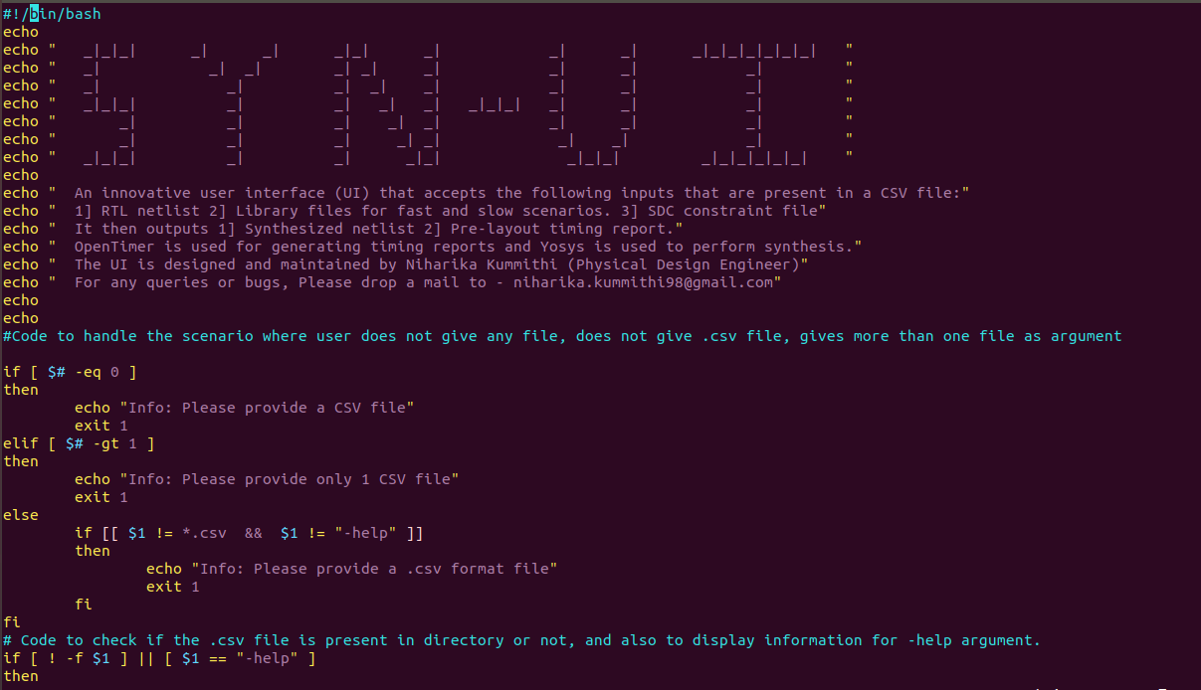

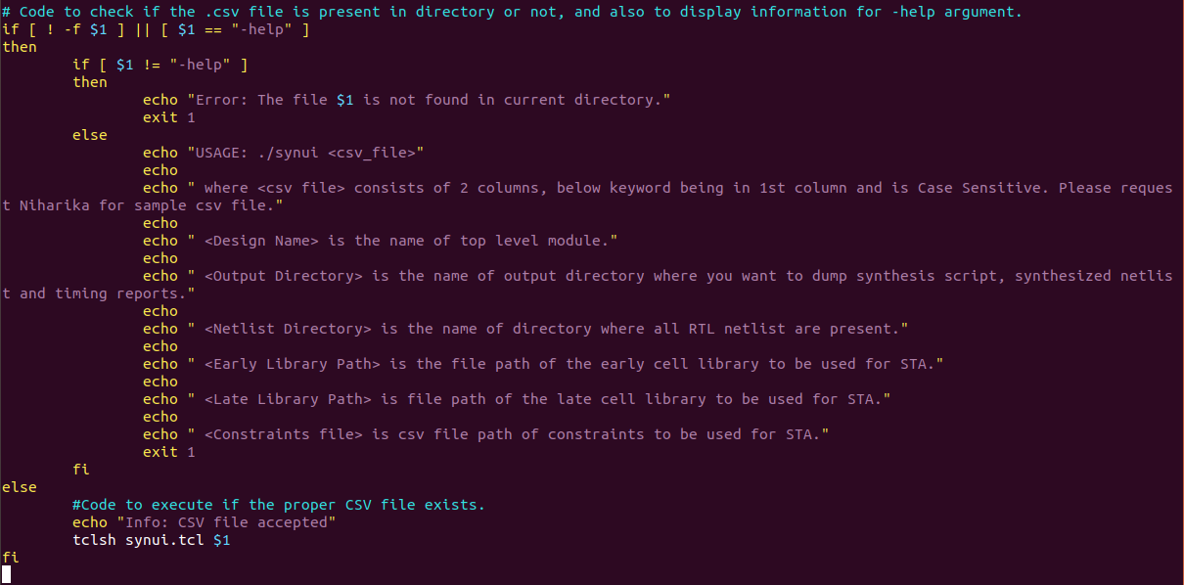

**Results**

Case 1: No input file

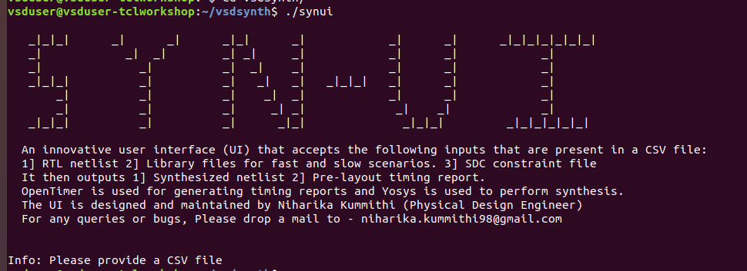

Case 2: File not of .csv format

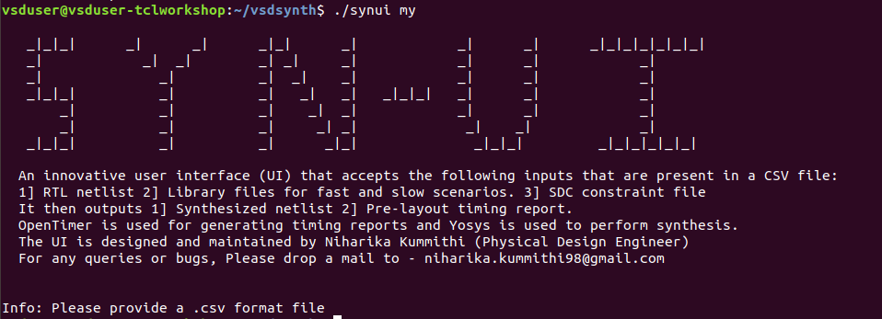

Case 3: More than 1 file given as input

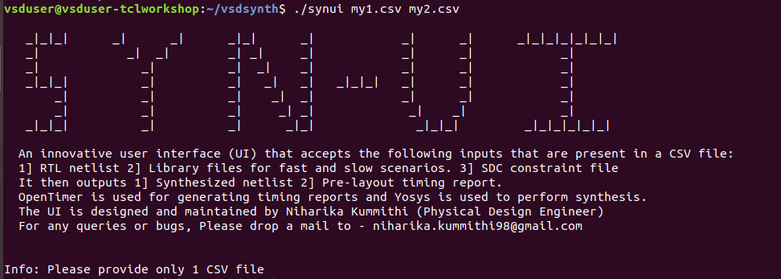

Case 4: The .csv file provided is not present in current directory.

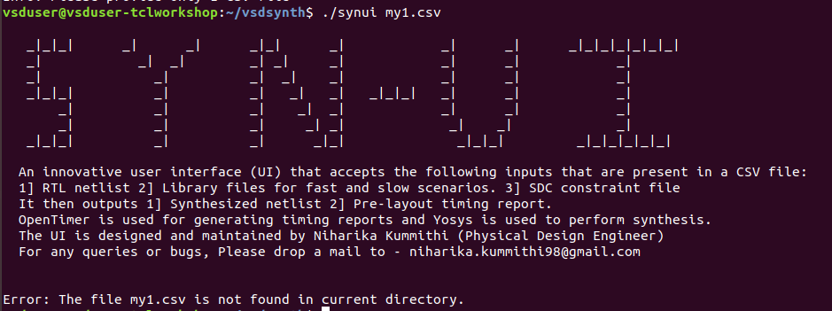

Case 5: Result of using the option ‘-help’

